
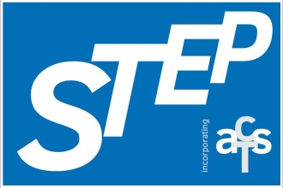


Scottish Teachers for Enhancing Practice
(incorporating the Association of Chartered Teachers Scotland)
Charity Number: SCO41390

National Education Conference

Saturday 14th March 2026

Stirling Court Hotel

BOOKING FORM
Name (please print):………………………………………………………………
School/Place of Work: ……………………………………………………………
Email address (work):……………………………………………………………
Email address (personal):……………………………………………………….
Local authority:…………………………………………………………………….
GTCS number: ………………………………………………………………………
Special dietary requirements/allergies: ………………………………….

I am a probationer teacher YES/NO please delete as appropriate

The early bird conference fee is £29.95 until 31st January. Thereafter the price is £45 until 2nd March, payable by BACS to STEP –
Sort Code 80-22-60, Account Number 12858861.
Please give your full name and GTCS number (where applicable) as the reference in the BACS payment details e.g. John Brown, GTCS No 10000.

WORKSHOP CHOICES
Session A - Morning
First choice Second choice

Session B - Morning
First choice Second choice

Session C - Afternoon
First choice Second choice

Please feel free to stay behind after the conference and attend the STEP AGM. Refreshments and a snack will be provided.

Please let us know now or at breakfast at the conference (STEP stall) any topics or issues you would like to discuss with your peers at our networking session:

Yes / No
STEP AGM after the conference

Cancellation Policy:
- Notification of cancellation must be received via email by 2nd March 2026 to conference@steachersep.org.uk. Please make sure you receive acknowledgement of this from the conference organiser if you cancel.
- After 2nd March 2026, there will be no refunds.
- Refunds will not be given for no-shows at the conference.
- If you book and your institute is paying for your attendance and you subsequently cancel after 2nd March 2026, your institute will still be required to make payment in full.
Please email this form to conference@steachersep.org.uk
no later than 2nd March 2026

